Bike Purchase Dashboard
This project presents an interactive dashboard that analyzes customer demographics and behavior related to bike purchases.
The goal is to identify patterns and insights that explain who is more likely to purchase a bike based on factors such as income, age, gender, commute distance, education level, marital status, and region.

Data Cleaning & Preparation
Before analysis, the dataset was cleaned and prepared to ensure accuracy and consistency.
Cleaning Steps Performed:
- Removed duplicate records
- Handled missing or inconsistent values
- Standardized categorical values (e.g., education levels, marital status)
- Grouped age into meaningful ranges
- Ensured correct data types for numerical and categorical fields
This step ensured the dataset was ready for analysis and visualization.

Pivot Table Analysis Included:
- Average income by gender and bike purchase status
- Count of bike purchases by age group
- Bike purchases vs commute distance

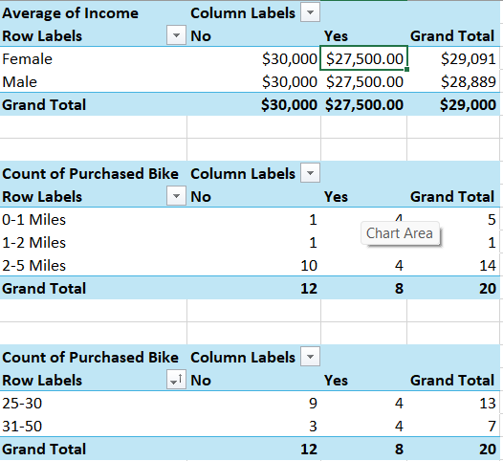

Dashboard Design
- The final dashboard was built using Pivot Charts and Slicers to allow dynamic exploration of the data

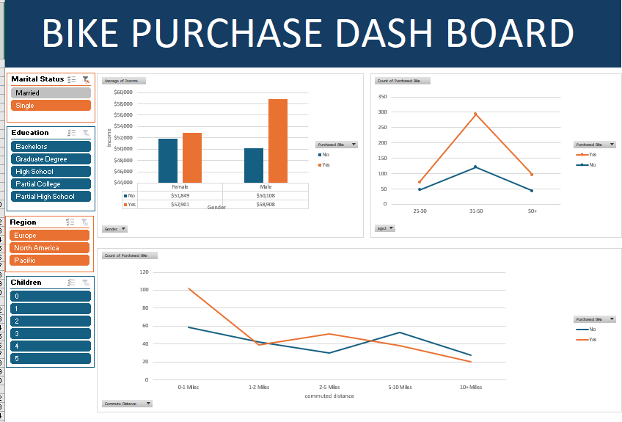

Key Insights
- Customers aged 31–50 are the most likely to purchase bikes
- Higher income is strongly associated with bike purchases
- Short to mid-range commuters show higher purchase rates
- Male customers who purchased bikes tend to have higher average income
- Demographic factors such as education and marital status influence purchasing behavior

Author
Malak Wessam
Faculty of Computers and Data Science

